|  |  |  |  |
| --- | --- | --- | --- |
| **F:\Learning bugs\Foundation Subjects\Dolly the Fly - Science.jpgLyng Primary School Knowledge Organiser** | | | |
| **Science** | **Plants** | **Year 1** | **Summer** |

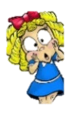

Botany is the study of plants.

Carolus Linnaeus was a Swedish botanist. He created two scientific systems: the system for classifying plants and animals and the system for naming all living things. Linnaeus is also called the Father of Systematic Botany.

**What should I already know?**

In Reception we have learned about understanding the world. We can:

Name some common plants.

Talk about plants

Describe plants using simple language.

|  |  |
| --- | --- |
| **What Step On and Goldilocks words will I use?** | |
| **Spelling** | **Definition** |
| flower | Part of a plant that attracts insects and birds |
| petal | Petals are part of a flowering  plant which attract insects,  such as bees. |
| leaf | Part of a plant which absorbs  sunlight which is used by the  plant to make food |
| root | Part of a plant which takes in  water and nutrients from the  soil |
| stem | Part of a plant which helps  support it and keep it upright |
| seed | The part of a flowering plant  that can grow into a new plant |
| bulb | Bulbs are underground masses of food storage from which plants grow |

C:\Users\dominic.cooper\AppData\Local\Microsoft\Windows\INetCache\Content.MSO\A3480DB6.tmp

|  |
| --- |
| **Investigate!** |
| * How plants grow. * Grow plants from seed and observe them as they grow and change. * Identify different parts of a plant. |
| Enquiry questions |
| * **What is a plant?** * **What are the different parts of a plant?** * **What is the difference between wild and garden plants?** * **How do trees change with the seasons?** * **Are all the seeds the same?** * **Which plant parts can you eat?** |

**What will I know by the end of the unit?**

|  |  |  |  |
| --- | --- | --- | --- |
| Plants | |  |  |
| **What is a plant?** |  | **How do trees change with the seasons?**  Identify and name a variety of common plants, including garden plants, wild plants and trees and those classified as deciduous and evergreen. |  |
| **What are the different parts of a plant?** Identify and describe the basic structure of a variety of common flowering plants, including roots, stem/trunk, leaves and flowers. |  | **Are all the seeds the same?** Find out and describe how plants need water, light and a suitable temperature to grow and stay healthy. |  |
| **What is the difference between wild and garden plants?**  Observe and describe how seeds and bulbs grow into mature plants. |  | **Which plant parts can you eat?** |  |

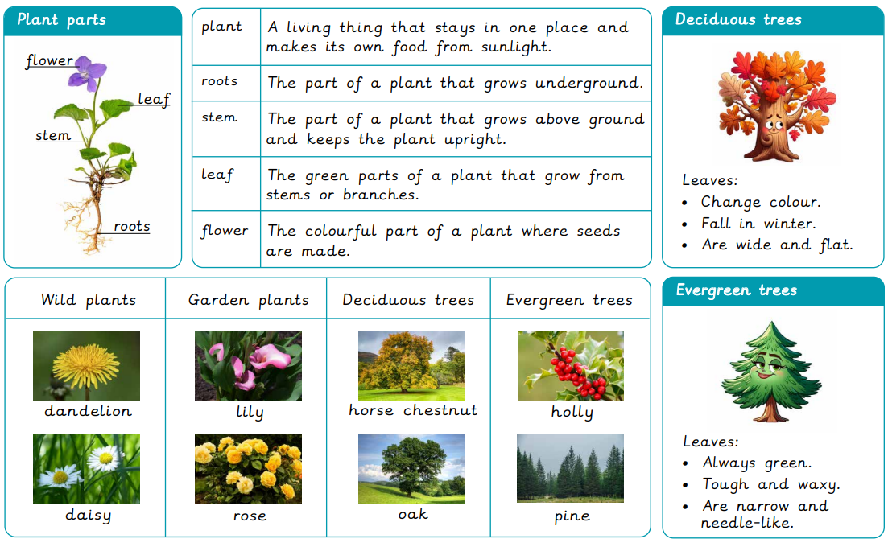

|  |  |  |  |
| --- | --- | --- | --- |
| **F:\Learning bugs\Foundation Subjects\Dolly the Fly - Science.jpgLyng Primary School Knowledge Organiser** | | | |
| **Science** | **Plants** | **Year 1** | **Summer** |

|  |  |  |  |
| --- | --- | --- | --- |
| 1. Write down the name of a wild plant from the UK. | **start** | | **end** |
|  |  |  | |

|  |  |  |
| --- | --- | --- |
| 4. What could happen if I plant a seed? | **start** | **end** |
|  |  |  |

|  |  |  |
| --- | --- | --- |
| 5. What do plants need to grow well? | **start** | **end** |
| 1. Being spoken to. |  |  |
| 1. Only water |  |  |
| 1. Water, sunlight and a suitable temperature. |  |  |
| 1. Hugs and kisses. |  |  |

|  |  |  |
| --- | --- | --- |
| 1. My tree has orange leaves in the autumn. Is it evergreen or deciduous? | **start** | **end** |
| 1. evergreen |  |  |
| 1. deciduous |  |  |

|  |  |  |
| --- | --- | --- |
| 1. Which part of the plant is in the ground? | **start** | **end** |
| 1. leaf |  |  |
| 1. petal |  |  |
| 1. roots |  |  |